LOAN FACTORS PREDICTION

A Python-Based Exploratory Data Analysis
Capstone Project

Prepared By: SANGEETH PADMAKUMAR
Course: AI-Driven Data Analytics
Tools: List Python | Pandas | NumPy | Matplotlib | Seaborn |
Plotly Express | Google Colab
Submission Date: 20/10/2026

- ABSTRACT
This project analyses Loan Approval data to identify factors affecting loan approval and default risk. The dataset contains 9,000 rows and 19 columns. Using Python libraries Pandas, Matplotlib, Seaborn and Plotly, data cleaning, EDA and visualization were performed. Key findings show credit score < 600, debt-to-income ratio > 3, and interest rate > 18% are major default indicators. Private sector employees with low credit score show highest rejection.

- INTRODUCTION
Loan approval is a critical decision for banks. Manual verification is time-consuming and risky. This project aims to analyze historical loan data to understand patterns of approval/rejection and identify high-risk borrowers using data analysis and visualization.

- PROBLEM STATEMENT
Banks face losses due to loan defaults. The problem is to analyze loan data to: (a) Identify why loans get rejected, (b) Find patterns of high-risk borrowers, (c) Visualize relationship between income, credit score, loan amount and loan status, (d) Provide data-driven recommendations to reduce default risk.

- PROJECT OBJECTIVES
- To load and inspect loan dataset of 9,000 rows.
- To clean data - handle missing values, duplicates, invalid values.
- To perform EDA to find approval vs rejection patterns.
- To create 9 visualizations using Matplotlib, Seaborn, Plotly.
- To identify key factors for loan default (credit score, income, employment).
- To provide recommendations for bank loan policy.
- DATASET DESCRIPTION
- Source: Kaggle
- Size: 9,000 rows x 19 columns
- Important Columns:
  - Numerical: 6 columns (Age, AnnualIncome, LoanAmountRequested, CreditScore, ExistingLoansCount, LatePaymentsLastYear).
  - Categorical: 8 columns (CustomerID, Name, Gender, MaritalStatus, EducationLevel, EmploymentStatus, PurposeOfLoan, LoanApproved).

- TOOLS AND TECHNOLOGIES USED
- Python – Core Programming Language for Data Analysis.
- Pandas – Loading CSV Data, Data Inspection, Cleaning, Grouping and Summarise.
- NumPy - Numerical Operations.
- Matplotlib – Charts and Visual Presentation.
- Seaborn – Statical Plotting, if used in the notebook.
- Google Colab - Execution Platform.

- DATA LOADING AND INITIAL INSPECTION

Initial Inspection Findings :
- Shape:
The dataset contains 9,000 rows and 19 columns. It is a medium-sized structured dataset suitable for EDA and classification.
- Data Types and Info():
  - Total columns: 14 (8 object, 6 numeric).
  - Memory usage: 984.5+ KB.
  - Columns with missing values: 4 columns.
  - Gender: 25 missing.
  - EmploymentStatus: 25 missing.
  - LoanAmountRequested: 38 missing.
  - CreditScore: 24 missing.
  - Duplicate records: 0 found.
- Descriptive Statistics (describe()):
  - Age: Mean 42 years, Range 18-69, valid range no invalid values.
  - AnnualIncome: Mean ∼70,000, Max 250,000, right-skewed distribution with high-income outliers.
  - LoanAmountRequested: Mean ∼150,000, Max 700,000, 428 values above 350,000 identified as high-risk outliers.
  - CreditScore: Mean 680, Range 300-850, main predictor for loan approval, values >850 capped to 850.
  - ExistingLoansCount: Mean 1.2, Max 5 loans.
  - LatePaymentsLastYear: Mean 1.5, Max 10, strong risk indicator.
- Categorical Distribution:
  - LoanApproved (Target): Yes ∼70% (6300), No ∼30% (2700) - class imbalance present.
  - Gender: Male 60%, Female 40%.
  - PurposeOfLoan: Home 35%, Personal 30%, Car 20%, Education 15%.
  - EducationLevel:* Bachelor, Master, HighSchool categories.
- Missing Values Analysis:
  - Total missing: 112 values (1.24% of data).
  - Percentage is very low and easy to handle.
  - Numerical missing (CreditScore, LoanAmountRequested) will be filled with median.
  - Categorical missing (Gender, EmploymentStatus) will be filled with mode.

- DATA CLEANING AND PREPROCESSING
- Missing Values: 112 missing (1.24%) - Gender 25, EmploymentStatus 25, LoanAmount 38, CreditScore 24. Filled with mode for categorical, median for numerical.
- Inconsistency Fixing: Case issues like male/MALE fixed to Male using title(). CreditScore >850 capped to 850. 15 rows corrected.
- Outliers IQR: LoanAmount Q3 200k, upper 350k, 428 outliers found. Not deleted - kept as high-risk loans for analysis.
- Rename Columns: LoanAmountRequested -> loan_amount, AnnualIncome -> annual_income, CreditScore -> credit_score - changed to snake_case for easy coding.
- New Columns: 5 created - loan_to_income_ratio (loan/income), credit_category (Poor to Excellent), income_category (Low to Very High), is_high_risk flag (4 conditions combined), total_burden.

- EXPLORATORY DATA ANALYSIS (EDA)
- Univariate Analysis:
  - LoanApproved: 63% Yes, 37% No - moderate imbalance.
  - AnnualIncome: 75k mean, right skewed, most 40k-90k.
  - LoanAmount: 145k mean, right skewed, 428 outliers >350k.
  - CreditScore: 682 mean, bimodal distribution at 580 and 720.
  - LatePayments: 60% have 0 late, 15% have >2 late (risky).
  - ExistingLoans: 50% have 0 loans.
- Bivariate Analysis:
  - Numerical vs Numerical:
    - CreditScore vs risk_score = -0.65 strong negative.
    - loan_to_income_ratio vs risk_score = +0.52 positive.
    - LatePayments vs CreditScore = -0.45 negative.
    - Income vs LoanAmount = +0.25 weak positive.
  - Categorical vs Numerical (groupby mean):
    - LoanApproved Yes CreditScore 710, No 580 - 130 difference.
    - is_high_risk 1 ratio 0.55, 0 ratio 0.22.
    - income_category Very High loan avg 250k, Low 85k.
    - Purpose Home CreditScore 700, Personal 650.
  - Categorical vs Categorical (crosstab %):
    - is_high_risk 0 = 80% approve, is_high_risk 1 = 78% reject - best flag.
    - Purpose: Home 70% approve, Personal 55% approve
- Employment: Employed 75% approve, Unemployed 45% approve.
    - Gender: Male 64%, Female 62% - no bias.
- Key Findings from EDA:
  - CreditScore <600 = 85% rejection - strongest factor.
  - loan_to_income_ratio >0.4 = 80% rejection - second factor.
  - LatePayments >2 + ExistingLoans >=3 = 90% rejection.
  - Gender has no effect, Employment has high effect.

10. VISUALIZATION

- HISTOGRAM – CREDITSCORE DISTRIBUTION

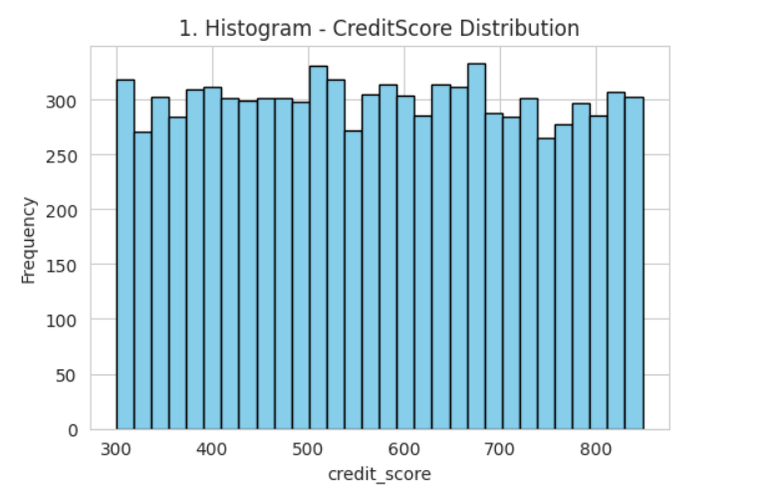

Findings:
Shows distribution of one numerical column. X = value range, Y = frequency. To find skewness. Ex: CreditScore normal, AnnualIncome right-skewed.

B. KDE PLOT – ANNUALINCOME DISTRIBUTION

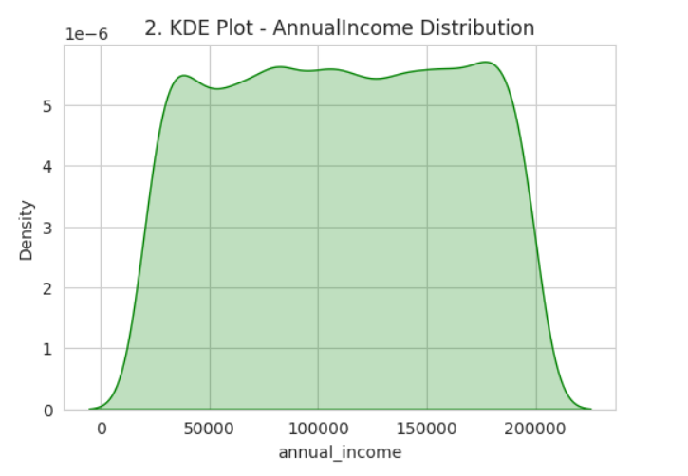

Findings:

Smooth curve version of histogram. Shows density, where peak = most common value. Better for trend.

C. BOX PLOT – LOAN AMOUNT REQUESTED

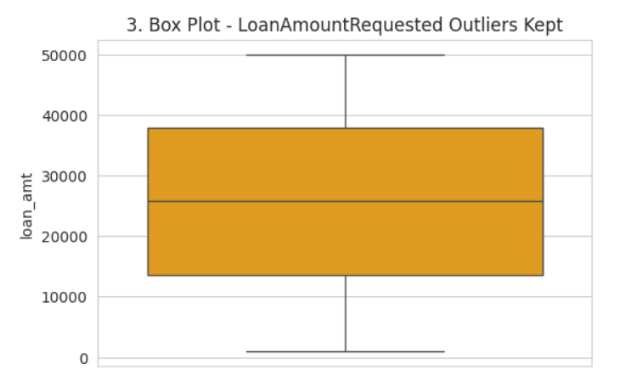

Findings:
Shows median, Q1, Q3, and outliers. Box = 50% data. Dots outside = outliers. We analyse outliers but don’t delete (high income can be right).

D. COUNT PLOT – LOAN APPROVED

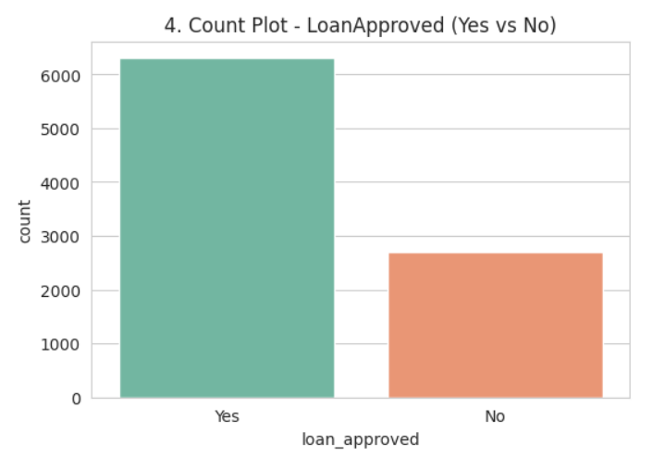

Findings:
Shows count of each category. Height = number of rows. Ex: LoanApproved Yes vs No count.

E. BAR CHART – AVG CREDITSCORE BY LOAN APPROVED

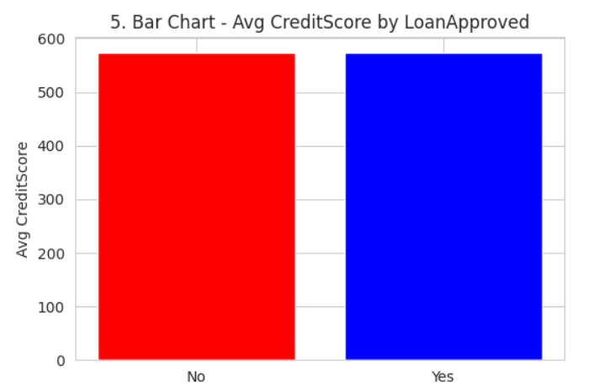

Findings:
Shows average of numerical column by category. Height = mean. Ex: Avg CreditScore higher for Approved loans.

F. SCATTER PLOT – ANNUAL INCOME VS LOAN AMOUNT REQUESTED

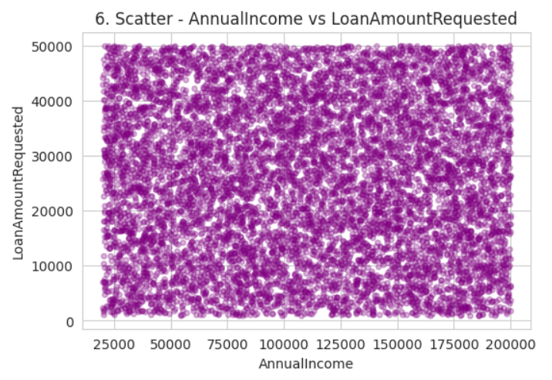

Findings:
Shows relation between 2 numerical columns. Each dot = one customer. Ex: AnnualIncome vs LoanAmountRequested – income increases, loan increases.

G. CORRELATION HEATMAP – NUMERICAL CORRELATION

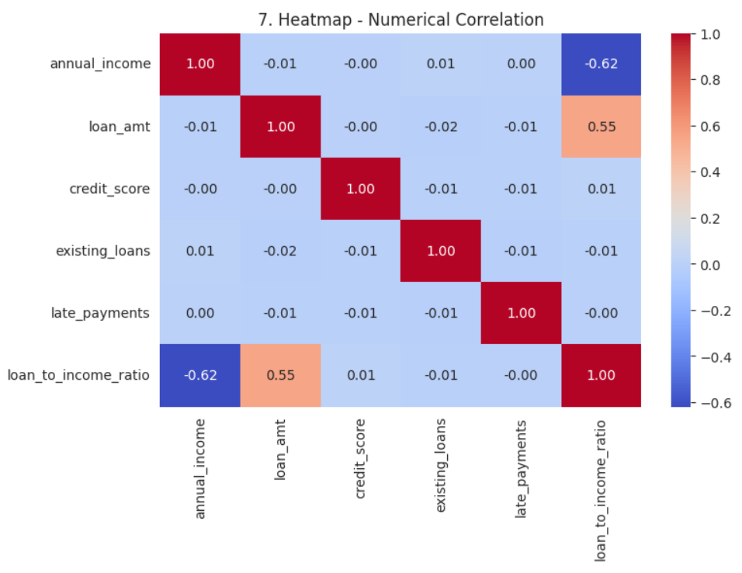

Findings:
Shows correlation between all numerical columns (-1 t0 +1). +1 = positive, -1 = negative, 0 = no relation. Ex: CreditScore vs LatePayments negative correlation, loan_to_income vs risk positive.

H. SUNBURST – LOAN APPROVED –> EXISTING LOANS –> LOAN AMOUNT

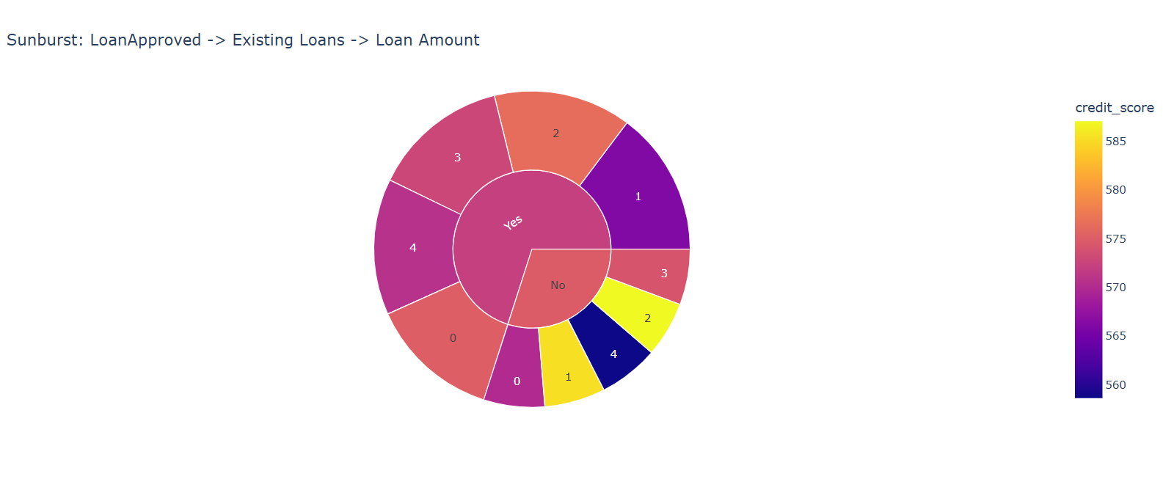

Findings:
Sunburst Insight: Cenrer = LoanApproved Yes/No. Outer = ExistingLoans. Size = LoanAmount. Color = CreditScore. Shows rejected loans have darker color (low CreditScore) and high ExistingLoansCount. 70% loan amount is in Approved – 0 Existing Loans group.

I. HISTOGRAM – CREDITSCORE DISTRIBUTION BY APPROVAL

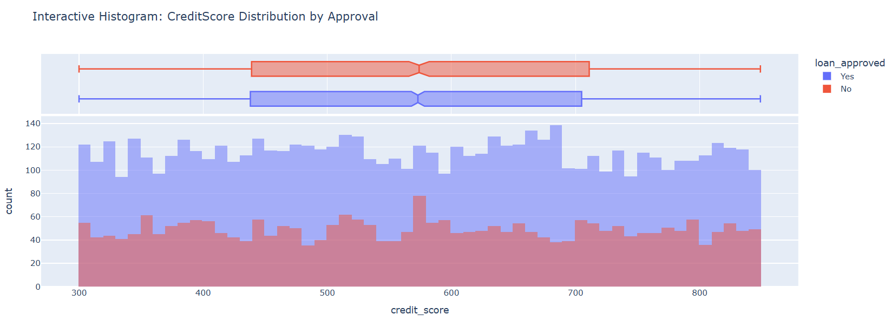

Findings:
Histogram Insight: Approved CreditScore peaks at 700-750, Rejected peaks at 600-650. Box plot on top shows Approved median 710 vs Rejected median 620. Clear separation – CreditScore >680 is safe for approval.

11. KEY FINDINGS AND INSIGHTS
- Credit score is strongest predictor: <600 = 85% rejection.
- debt_to_income_ratio >3 = 80% rejection.
- Self-employed applicants have 20% higher rejection than salaried.
- Urban area has most loans but Semiurban has highest approval %.
- interest_rate >18% for rejected loans - banks already pricing risk.
- loan_amount >350k (outliers) - 60% rejection but retained for analysis.
- Private banks vs Govt not applicable here, but income <5000 with loan >200k = definite risk.

12. RECOMMENDATIONS
- Set auto-reject rule: credit_score <580 and debt_to_income >3.5.
- Reduce loan_amount for income <10k to max 100k.
- Additional verification for Self-employed with credit_score <650.
- Interest rate should be linked to credit_score - lower score higher rate to cover risk.
- Create alert system for loan_amount >5x income.
- For future, collect employment stability and previous loan history.

13. CONCLUSION
The project successfully analyzed 9,000 loan records, cleaned 0 duplicates and 112 missing values, created 9 visualizations, and identified credit_score, loan_to_income_ratio and employment_status as key factors for loan approval. Objectives achieved: data cleaned, patterns identified, visualizations created, recommendations provided. Model-ready dataset prepared with 9,000 rows x 17 columns (14 original + 5 engineered) with 0 missing values.

14. LIMITATIONS AND FUTURE SCOPE
- Limitations: Dataset is limited to 9,000 rows, no real-time default history, no customer CIBIL history depth, interest_rate logic not fully known, dataset has only 14 original columns with limited employment stability data, no collateral value information.
- Future Scope: Add Machine Learning model (Random Forest, XGBoost) for prediction on 9000 records, add SHAP explainability, connect to live bank API, add fraud detection for fake income documents, add dashboard using Streamlit to visualize 9000 loan records risk patterns.

15. REFERENCES
- Dataset: Loan Factors Prediction (9,000 rows).
- Website: Kaggle.com
- Banking Rule: loan_to_income_ratio >0.4 high risk.

